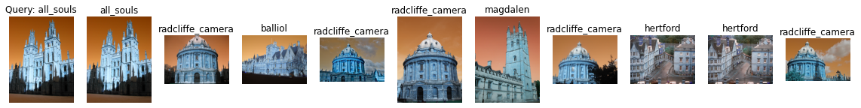

Label: all_souls

Average Precision for query 0: 0.19170340715177803

Precision@k for query 0: 0.1

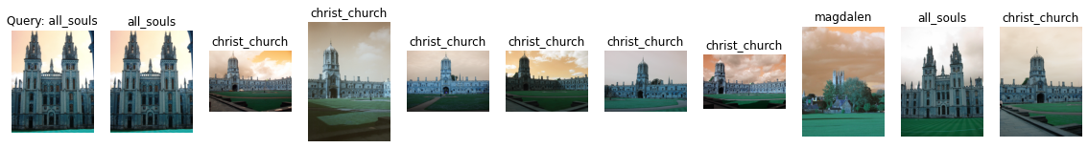

Label: all_souls

Average Precision for query 1: 0.1327546791905166

Precision@k for query 1: 0.2



Label: all_souls

Average Precision for query 2: 0.2612213020854161

Precision@k for query 2: 0.5

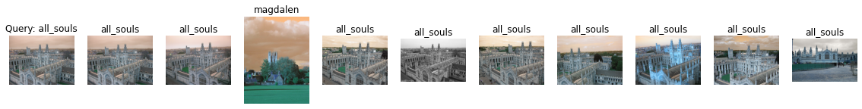

Label: all_souls

Average Precision for query 3: 0.34780579030563036

Precision@k for query 3: 0.9

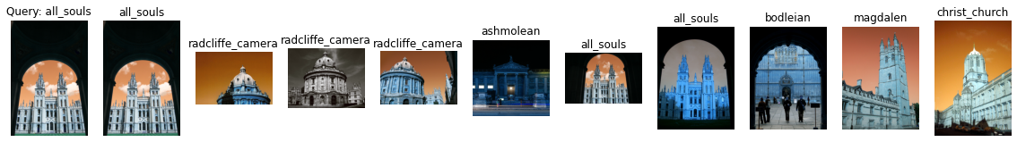

Label: all_souls

Average Precision for query 4: 0.242907131493254

Precision@k for query 4: 0.3



Label: ashmolean

Average Precision for query 5: 0.07404342307979861

Precision@k for query 5: 0.1

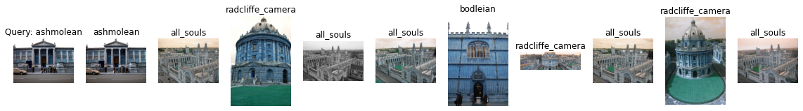

Label: ashmolean

Average Precision for query 6: 0.07919181540928531

Precision@k for query 6: 0.1

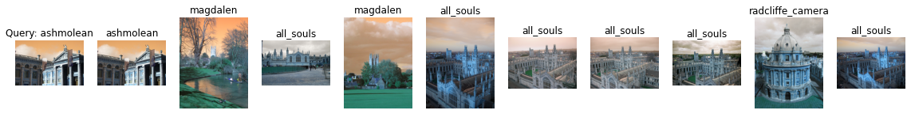

Label: ashmolean

Average Precision for query 7: 0.06986174101469304

Precision@k for query 7: 0.1

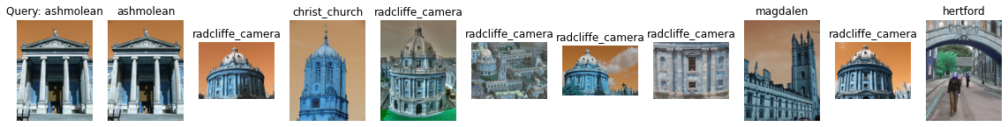

Label: ashmolean

Average Precision for query 8: 0.08619541309111829

Precision@k for query 8: 0.1

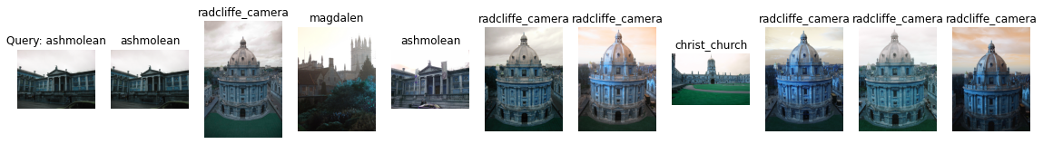

Label: ashmolean

Average Precision for query 9: 0.09659447441698657

Precision@k for query 9: 0.2

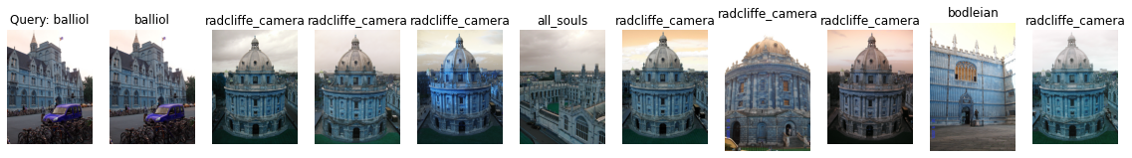

Label: balliol

Average Precision for query 10: 0.11337595953929175

Precision@k for query 10: 0.1



Label: balliol

Average Precision for query 11: 0.17789578559857266

Precision@k for query 11: 0.3

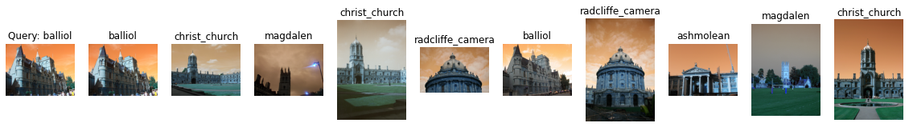

Label: balliol

Average Precision for query 12: 0.14906744022495597

Precision@k for query 12: 0.2

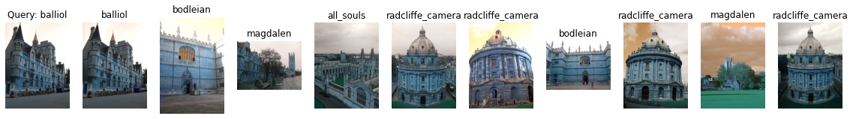

Label: balliol

Average Precision for query 13: 0.15919388365086481

Precision@k for query 13: 0.1

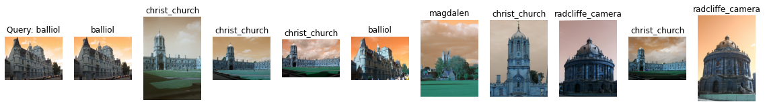

Label: balliol

Average Precision for query 14: 0.14620545566661466

Precision@k for query 14: 0.2

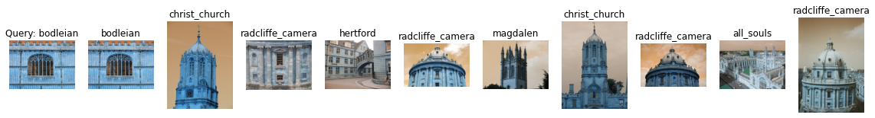

Label: bodleian

Average Precision for query 15: 0.10603706202875769

Precision@k for query 15: 0.1



Label: bodleian

Average Precision for query 16: 0.15008021963447257

Precision@k for query 16: 0.3

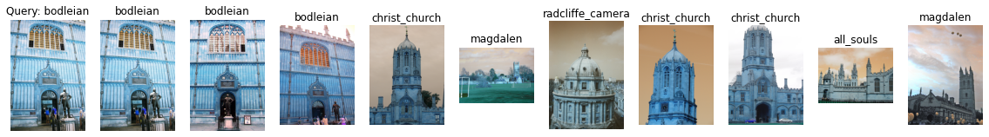

Label: bodleian

Average Precision for query 17: 0.19669299712653698

Precision@k for query 17: 0.3



Label: bodleian

Average Precision for query 18: 0.28747444466673994

Precision@k for query 18: 0.5

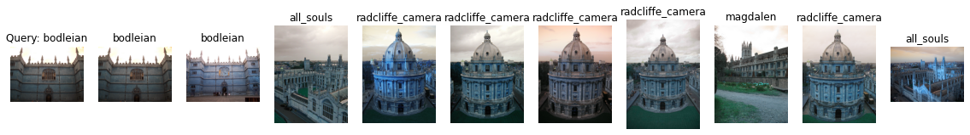

Label: bodleian

Average Precision for query 19: 0.17691195178031846

Precision@k for query 19: 0.2

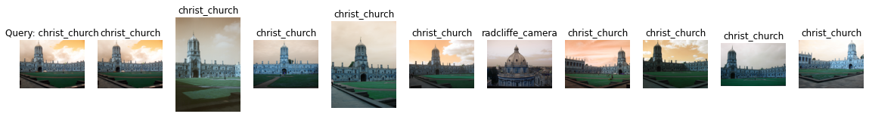

Label: christ_church

Average Precision for query 20: 0.4613401849746182

Precision@k for query 20: 0.9



Label: christ_church

Average Precision for query 21: 0.49098932352102936

Precision@k for query 21: 0.9

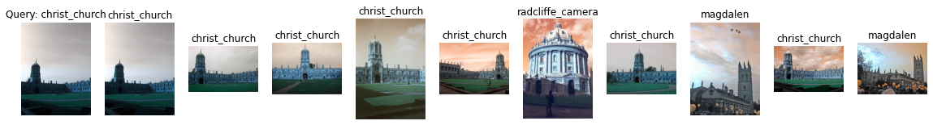

Label: christ_church

Average Precision for query 22: 0.4155871282979569

Precision@k for query 22: 0.7



Label: christ_church

Average Precision for query 23: 0.13421363242365106

Precision@k for query 23: 0.1

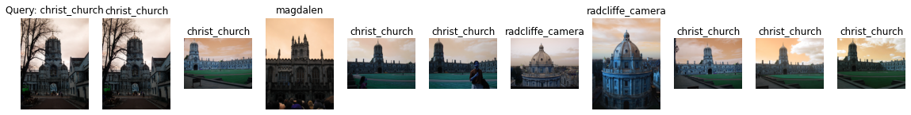

Label: christ_church

Average Precision for query 24: 0.3191770147330829

Precision@k for query 24: 0.7

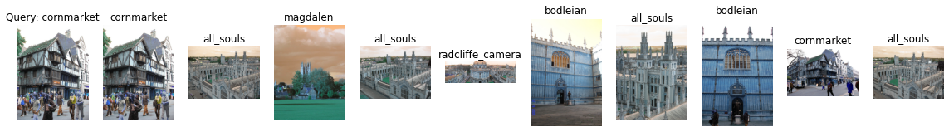

Label: cornmarket

Average Precision for query 25: 0.1590318274920079

Precision@k for query 25: 0.2

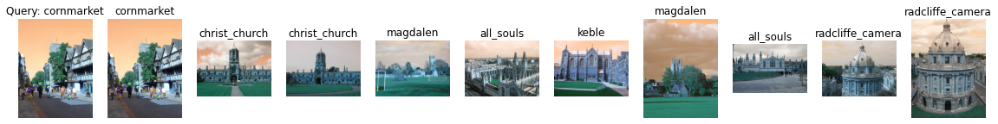

Label: cornmarket

Average Precision for query 26: 0.12139291063047507

Precision@k for query 26: 0.1

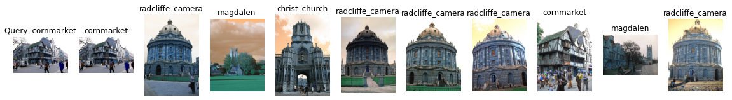

Label: cornmarket

Average Precision for query 27: 0.15904153551038377

Precision@k for query 27: 0.2

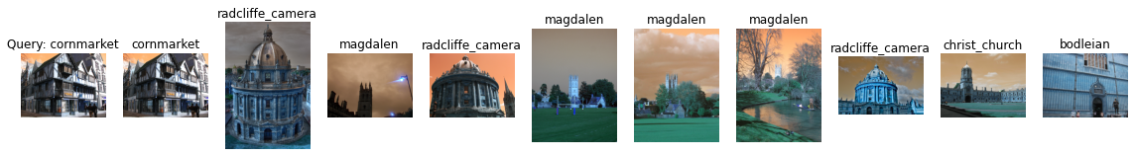

Label: cornmarket

Average Precision for query 28: 0.13068089956537873

Precision@k for query 28: 0.1

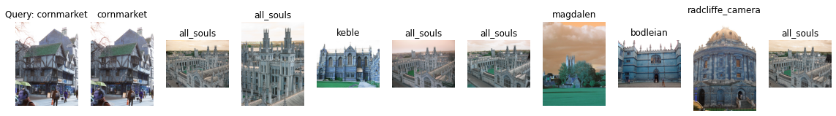

Label: cornmarket

Average Precision for query 29: 0.1311172636371762

Precision@k for query 29: 0.1

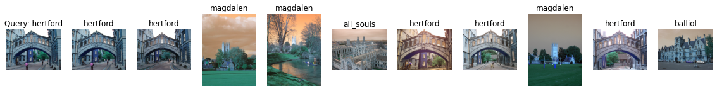

Label: hertford

Average Precision for query 30: 0.25913405188756017

Precision@k for query 30: 0.5



Label: hertford

Average Precision for query 31: 0.3545592452932358

Precision@k for query 31: 0.6



Label: hertford

Average Precision for query 32: 0.15223322638501713

Precision@k for query 32: 0.2

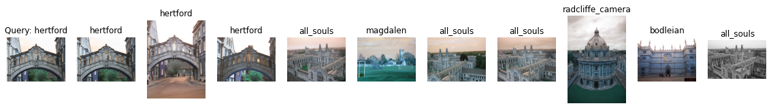

Label: hertford

Average Precision for query 33: 0.18951420431947755

Precision@k for query 33: 0.3

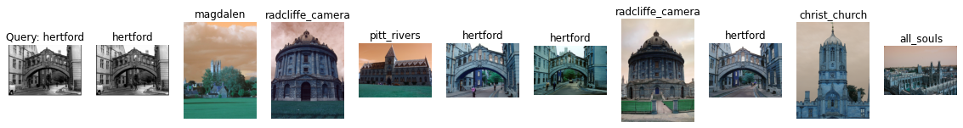

Label: hertford

Average Precision for query 34: 0.1714486161363481

Precision@k for query 34: 0.4

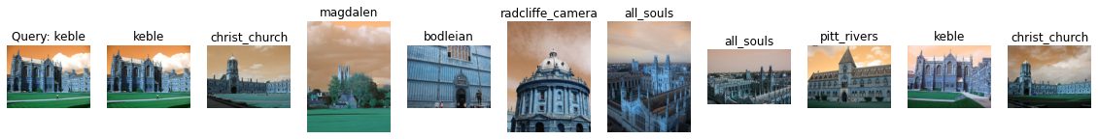

Label: keble

Average Precision for query 35: 0.18736430752470895

Precision@k for query 35: 0.2

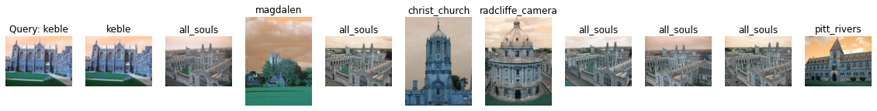

Label: keble

Average Precision for query 36: 0.16366296429615454

Precision@k for query 36: 0.1

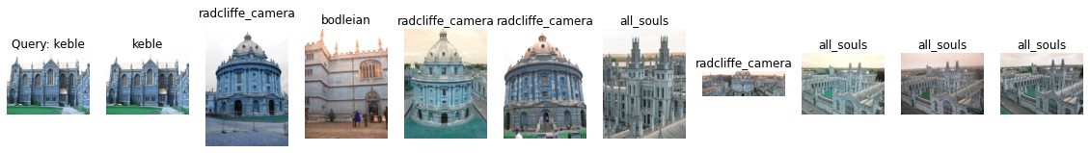

Label: keble

Average Precision for query 37: 0.16971785999093555

Precision@k for query 37: 0.1

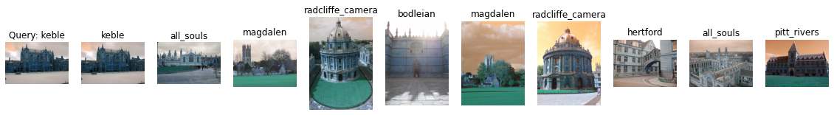

Label: keble

Average Precision for query 38: 0.18134444031979982

Precision@k for query 38: 0.1

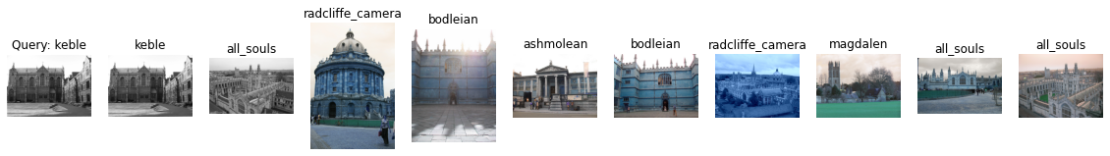

Label: keble

Average Precision for query 39: 0.17235242295485156

Precision@k for query 39: 0.1



Label: magdalen

Average Precision for query 40: 0.11248486621727449

Precision@k for query 40: 0.1



Label: magdalen

Average Precision for query 41: 0.13990902667327576

Precision@k for query 41: 0.2

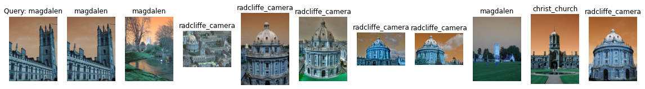

Label: magdalen

Average Precision for query 42: 0.15278845658172116

Precision@k for query 42: 0.3

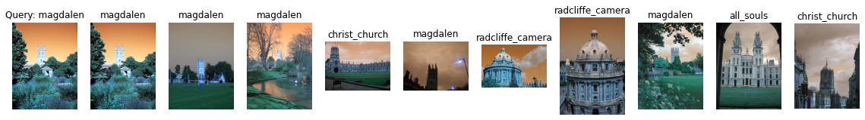

Label: magdalen

Average Precision for query 43: 0.1935058282166753

Precision@k for query 43: 0.5

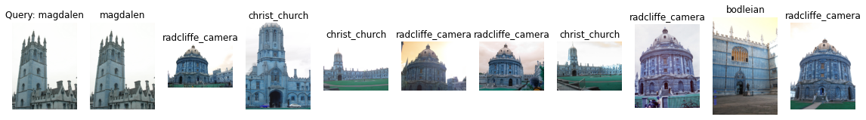

Label: magdalen

Average Precision for query 44: 0.0957876681515687

Precision@k for query 44: 0.1

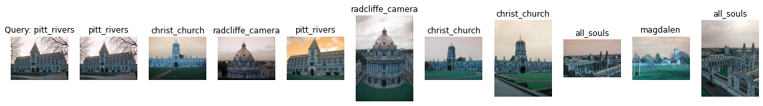

Label: pitt_rivers

Average Precision for query 45: 0.2653766135101434

Precision@k for query 45: 0.2

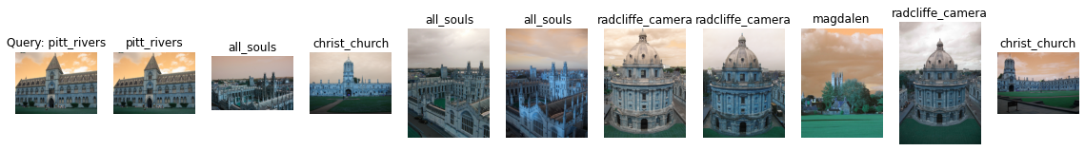

Label: pitt_rivers

Average Precision for query 46: 0.19147865627202296

Precision@k for query 46: 0.1

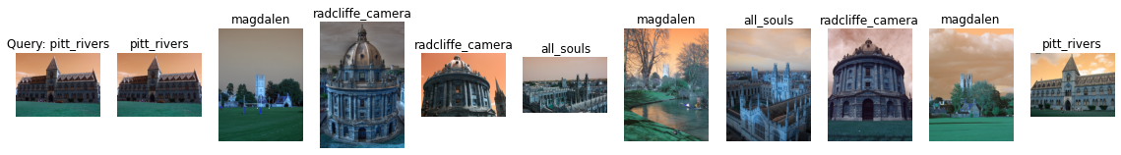

Label: pitt_rivers

Average Precision for query 47: 0.2109367423490022

Precision@k for query 47: 0.2

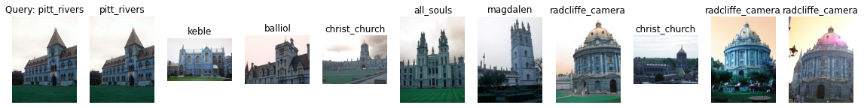

Label: pitt_rivers

Average Precision for query 48: 0.19419380994912072

Precision@k for query 48: 0.1



Label: pitt_rivers

Average Precision for query 49: 0.18584097690130233

Precision@k for query 49: 0.1

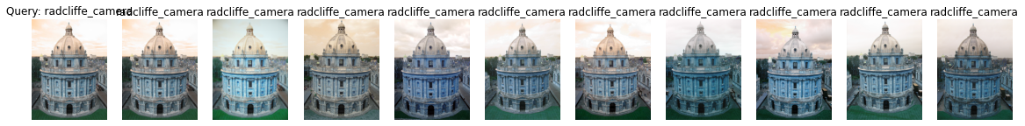

Label: radcliffe_camera

Average Precision for query 50: 0.5158417347592114

Precision@k for query 50: 1.0



Label: radcliffe_camera

Average Precision for query 51: 0.431427455378647

Precision@k for query 51: 0.5

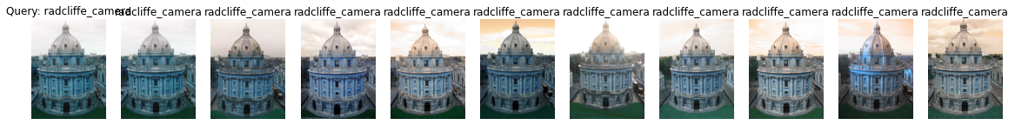

Label: radcliffe_camera

Average Precision for query 52: 0.5234638454675512

Precision@k for query 52: 1.0

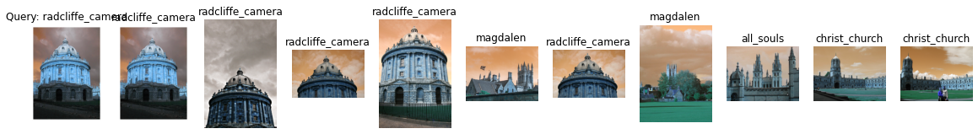

Label: radcliffe_camera

Average Precision for query 53: 0.39442301996932344

Precision@k for query 53: 0.5

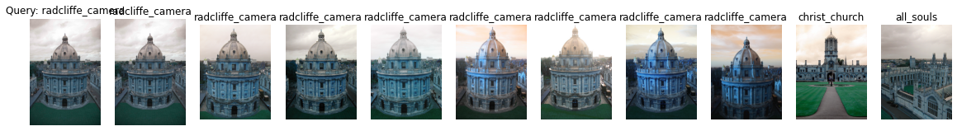

Label: radcliffe_camera

Average Precision for query 54: 0.4711433530340953

Precision@k for query 54: 0.8

mAP=0.215413081645098